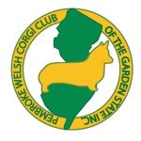

Pembroke Welsh Corgi Club of the Garden State

Delaware Valley Cardigan Welsh Corgi Association

Herding Instinct Test – Saturday, November 2, 2024

Please note that we will abide by local and state requirements regarding COVID that are in place at the time of the HIT.

Entries can be sent at any time. However, entries from members of the two sponsoring clubs will have preference until October 5, 2024.
After that date all entries will be accepted, by postmarked date,
for all Corgis and other herding breeds.
All entries close on October 29, 2024.

Please print your email address and phone number clearly on the entry.
This is how we will contact you about the status of your entry.

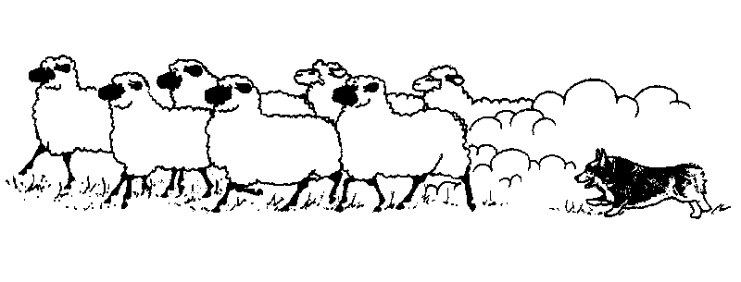
Time: 8:30 AM – 2:30 PM

Limit: 24 dogs
Fee: $50/dog
Tester: Katherine Spence

Stock: Well dog-broke mixed breed sheep
Location: 25 Stokes Rd, Shamong, NJ
Checks: PWCCGS
Entries: Pre-Entry only and all entries close on October 29, 2024

Send Entries To: Sally Felix
23 Llanfair Lane
Ewing, NJ 08618
Information: daydreamcorgis@gmail.com Cell: 605-261-8239

Dogs must be at least 6 months old.

For the Herding Instinct Test, dogs need have NO training on stock. Any dog endangering stock by biting or excessive chasing will be excused.

Any dog showing aggression toward people in or out of the ring will be asked to leave the grounds.

All dogs must have proof of current rabies vaccination available for inspection if requested. If your dog is showing any signs of illness or just not feeling well, please do not bring him/her.

Bitches in heat may take part in the test, but must wait until all other dogs have participated. Please indicate this on the registration form, if known when submitting.

Dogs must be on leash at all times except while competing. Please bring a buckle collar and lead for your dog for the test. For their safety, children must be under supervision at all times, and not allowed to run around the farm or climb on fences or equipment. Unruly children will be asked to leave the grounds.

You will be assigned a fifteen-minute time period. Please check your confirmation and be on time. We strongly suggest you plan to arrive at least ½ hour before your scheduled time, to allow for absences and dogs who do not use the entire 15 minutes they are allotted.

GENERAL INFORMATION:

ENTRIES/RELEASE-You must use the entry form provided at the end of this document. The release must be signed by all adults (and for minors) who will be in attendance. Additional forms will be available at the test.

CONFIRMATION OF ENTRY will be sent after entries close with your dog’s scheduled time. Please enclose a check with your RSVP form to secure a spot. Checks are not cashed until after the test.

DRESS - This is a working farm and you will be walking in areas that sheep sometimes inhabit. Please dress appropriately - long pants, old shoes. Be aware we will be working rain or shine, so bring your rain gear.

IMPORTANT - Keep all dogs at least 50 feet away from arena on a leash or in a crate. Pick up after your dogs and do not litter.

SPECIAL REQUIREMENTS - Please bring chairs, water for your dog, bug spray, and any other special items you or your dog may require. There will be no food available at the farm. There is a restaurant a short distance from the farm.

DIRECTIONS: NJ Turnpike South to Exit #7/BORDENTOWN/TRENTON
US-206 South. Go 8.3 miles south of the Red Lion Circle (i.e., the intersection of Rt 206 and Rt 70).
Turn right toward Medford onto Stokes Rd (also called Rt 541).
House is third on left. Brown house with a brown fence that goes right up to the road.
PWCCGS/DVCWCA Herding Instinct Test

ENTRY FORM FOR DOG/HANDLER
25 Stokes Rd, Shamong, NJ 08088-9449

November 2, 2024
Dog’s Call Name:
Registered Name:
Breed:
Date of Birth: Sex: AKC#:

Cost: $50 per dog for test
Make check out to PWCCGS (no refunds and payment is due prior to closing for a space)

Send completed form and check to:

Sally Felix

23 Llanfair Lane
Ewing, NJ 08618
605-261-8239
daydreamcorgis@gmail.com

Your participation in this test is undertaken without liability on the part of the Pembroke Welsh Corgi Club of the Garden State: the board / officers / members; the Delaware Valley Cardigan Welsh Corgi Association: the board / officers / members; Katherine Spence, or any member of her staff for any loss or damage for disease, injury, running away, theft, fire, or any other cause whatsoever, and you agree to hold harmless the PWCCGS, its board / officers / members, the DVCWCA, its board/ officers / members, Katherine Spence, other instructors / testers, and their families, and other employees, and owners of the property from any resulting damages resulting from said occurrence.
It is also understood that you agree to pay any livestock injuries or replacement value in the event of death of any livestock caused by your dog.

If these terms are acceptable to you, and to cover minor children, both the owner and / or handler, plus any adults in attendance must-sign below:

ACCEPTED ______
Owner’s Name:
Address: ______
City: State: Zip:
Phone #: Handler’s Name:
Email address: _____

